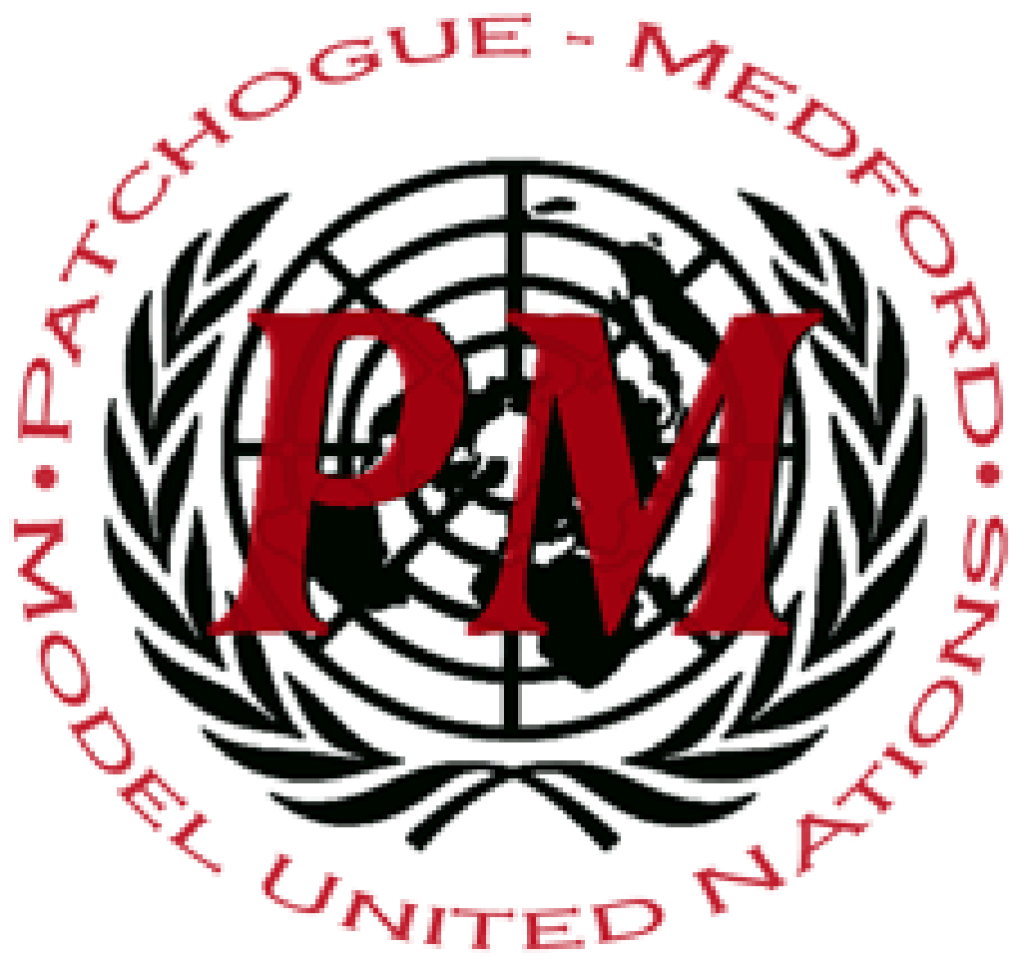
PatMedMUNCXII
European Union Parliament

Hello Delegates! We are your chairs, Constantine Viennas and John Werner, and we are excited to have you in our committee this year. In this document is some basic information to aid you in your understanding of the committee, to ensure that you walk into the conference fully prepared to make this committee a truly incredible experience.
Each delegate will be representing a political party within the European Parliament. After the formation of the new Parliamentary Groups after the 2019 European elections, we apportioned the committee’s planned seats into the groups: The European United Left/Nordic Green Left (GUE-NGL), Greens-European Free Alliance (Greens-EFA), Progressive Alliance of Socialists and Democrats (S&D), Renew Europe, The European People’s Party (EPP), European Conservatives and Reformists (ECR), Identity and Democracy (ID), and Non-Inscrits (NI). The apportionment proceeded as follows:

European United Left-Nordic Green Left: 2 Seats
Greens-EFA: 3 Seats
Progressive Alliance of Socialists and Democrats: 5 Seats
Renew Europe: 5 Seats
European People’s Party: 6 Seats
European Conservatives and Reformists: 3 Seats
Identity and Democracy: 3 Seats
Non-Inscrits: 2 Seats

Though not every committee provides its delegates with this information, we thought that you would be in a better position if you knew what parties were going to be appearing in committee.

European United Left-Nordic Green Left:
- Syriza (Greece)
- Podemos (Spain)

Greens-EFA:
- Alliance 90’ The Greens (Germany)
- Green Party (Sweden)
- Lithuanian Farmers and Greens Union (Lithuania)

Progressive Alliance of Socialists and Democrats:
- Democratic Party (Italy)
- Social Democratic Union (Germany)
- Spanish Socialist Workers Party (Spain)
- Social Democratic Party (Sweden)
- Labour Party (UK)

Renew Europe:
- Ciudadanos (Spain)
- Reform Estonia (Estonia)
- En Marche! (France)
- Venstre (Denmark)
- ANO 2011 (Czechia)

European People’s Party:
- New Democracy (Greece)
- Civic Platform (Poland)
- Austrian People’s Party (Austria)
- The Republicans (France)
- Fidesz (Hungary)
- National Liberal Party (Romania)

European Conservatives and Reformists:
- Law and Justice (Poland)
- Forum for Democracy (Netherlands)
- Sweden Democrats (Sweden)

Identity and Democracy:
- National Rally (France)
- Alternative For Germany (Germany)
- La Lega (Italy)

Non-Instricts:
- Brexit Party (UK)
- Movement 5 Star (Italy)

The parties will act as countries would in any other committee, able to make resolutions in the typical MUN format and vote on them, with each party receiving one vote. The parties within each of the eight parliamentary groups do not have to work together, but if an agreement is made the entire group may sponsor a resolution, with all members included as sponsors. In addition, an entire group may function as a signatory.
Ex: Identity and Democracy sponsors an anti-migration resolution that all individual members have agreed on. The sponsors, though listed as just Identity and Democracy, automatically include National Rally, Alternative for Germany, and La Lega. The European People’s Party agrees to be a signatory, with all members in agreement. While listed as just the EPP, this includes all EPP members. Additionally, Reform Party Estonia is a signatory, and is listed as such.
Delegates are expected to have an extremely detailed knowledge of their party’s positions on the issues at hand in committee. The best way to find information is to enter the internet code (Ex: Denmark = google.dk ) for your party’s country, and search for the party’s website. Parties will have a manifesto or platform available for viewing. News from your party’s country is also a great place to look.
We are extremely excited to have you all in committee! Good luck!

