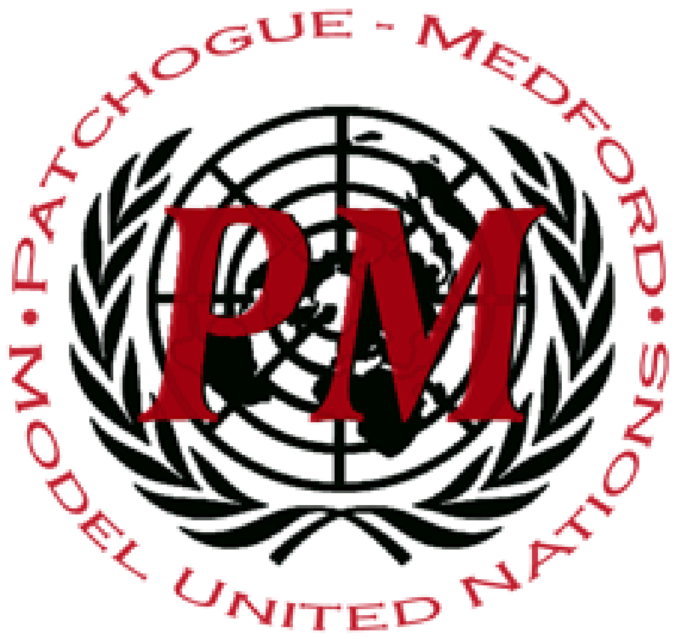
Distinguished delegates,
Welcome to Patchogue-Medford MUNC XII Human Rights Council! We are your chairs Ishika Patel and Ronald Lospenuso. We are very excited that you are attending our conference and chose to spend your weekend attempting to find solutions to some of our world’s greatest issues pertaining to HRC. The topics for this committee are: Incidents of Hate Crimes and Protecting Freedoms to Assemble and Protest.
My name is Ishika Patel and I am a freshman at Stony Brook University. I began my Model UN career as a freshman in high school and the impact it has had on me is amazing. It has improved my public speaking skills and helped me learn how to work with others more efficiently. The friends and memories I made in my Model UN career motivated me to return as an alumni chair and hopefully give delegates an amazing experience. At Stony Brook, I am aspiring to be a part of the Volunteer Ambulance Corps, Global Medical Brigades, and a community service club that works to organize blood drives on campus. I plan on double majoring in Biology and Computer Science.
My name is Ronald Lospenuso and I am also a freshman at Stony Brook University. I started Model United Nations as a freshman in high school. I fell in love with the club and became treasurer in tenth grade and secretary general in eleventh and twelth grade. I am not returning to chair this conference because I remain local, but because I miss the experience and the friends I have made. At Stony Brook University, I am majoring in both biology and applied mathematics. Lately I enjoy spending time with my friends, writing, and playing ultimate frisbee.
We are so excited to get to know you all at this upcoming conference. We hope to see some great debate and diplomacy from new and returning delegates. Come prepared and well informed and we’ll see you soon!

Sincerely,
Ishika Patel and Ronald Lospenuso

