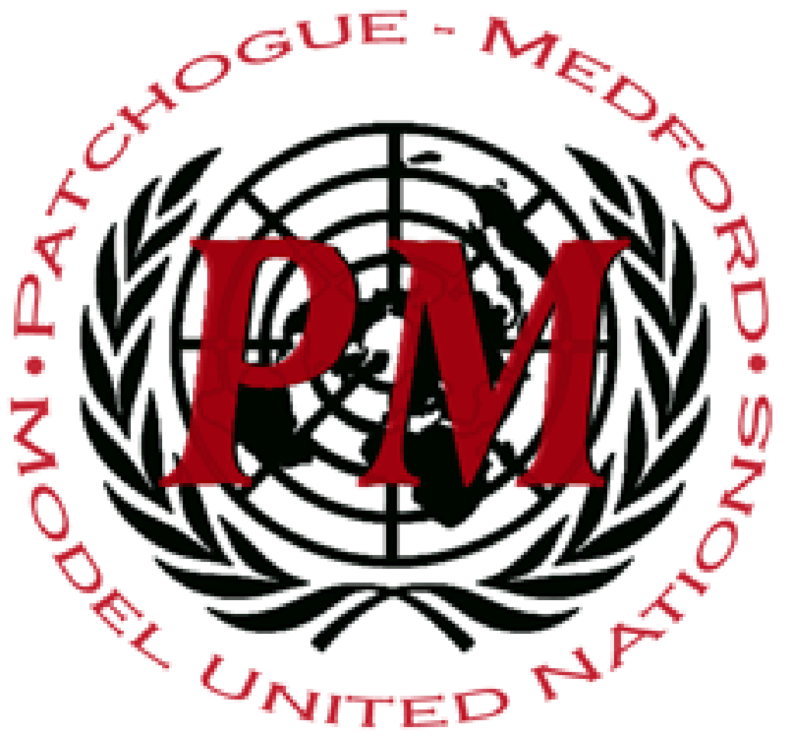
PatMedMUNCXII
General Assembly

Illicit Organ Trade

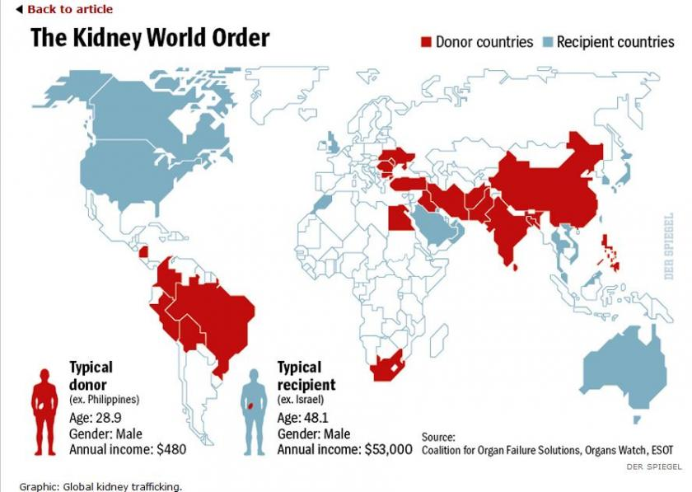
Ever since there has been a demand for healthy organs for patient transplants, an illegal, black market trade has existed. This is primarily caused by the fact that there is more of a demand for organs then there are healthy organs for transplant. Illegal traffic of controlled goods and services, or the black market, has major implications for the international community. As medical technology advances, the increasing activity of the medical black market is apparent and goods such as prescription drugs, medical equipment, and organs are being exchanged. Criminal networks increasingly engage in kidnappings, especially of children and teenagers, who are then taken to locations with medical equipment. There they are murdered and their organs harvested for the illegal organ trade. The international community has issued many ordinances and declarations against the organ trade.
Examples include the World Medical Authority's 1985 denouncement of organs for commercial use; the Council of Europe's Convention on Human Rights and Biomedicine of 1997 and its 2002 Optional Protocol Concerning Transplantation of Organs and Tissues of Human Origin; and the Declaration of Istanbul on organ trafficking and transplant tourism. The Declaration of Istanbul defines transplant commercialism, organ trafficking, and transplant tourism. The Declaration of Istanbul condemns these practices based on violations of equity, justice, and human dignity. The declaration aims to promote ethical practices in organ transplantation and donation on an international level. It is nonbinding, but over 100,000 transplant organizations support its principles, such as The Transplant Society, International Society of Nephrology, The National Foundation for Transplants and The American Transplant Foundation. The World Health Organization has also played a prominent role in condemning the illegal organ trade. The WHO first declared organ trade illegal in 1987, stating that such a trade violates the Universal Declaration of Human Rights.
WHO also condemns the practice on the grounds that it "is likely to take unfair advantage of the poorest and most vulnerable groups, undermines altruistic donation and leads to profiteering and human trafficking.” In 1991, at the 44th World Health Assembly, it approved nine guiding principles for human organ transplants. The principles clearly stated that organs cannot be the subject of financial transactions. On May 22, 2004, these guidelines were slightly amended at the 57th World Health Assembly. They are intended for the use of governments worldwide. These global initiatives have served as a helpful resource for establishing medical professional codes and a legal framework for the issue, but have not provided the sanctions required for enforcement.
The reason why Illegal Organ Trade is such a serious topic in the United Nations is because of the number of deaths revolving around it and the money it brings in illegally. It is estimated that most sellers get $2000 - $6000 for just one kidney, making it a go-to for making money illegally. Along with this, death counts are also a serious concern. Because live, healthy organs are required to trade, people are needed to harvest from. Due to the number of organs needed to fulfill demands, many people take it into account to legally acquire healthy organs or sell healthy organs. Most organs that are exchanged through this system are from killings and kidnappings.
Points to Consider:
- Is your nation prevalent in this trade?
- What does your nation do to prevent these trades?
- What laws does your nation have in correspondence to this issue?
- How does your nation contribute to stopping these problems?
Helpful links:
https://www.independent.co.uk/voices/organ-trade-dealing-donation-illegal-black-market-donors-transplants-a8461216.html
https://www.acamstoday.org/organ-trafficking-the-unseen-form-of-human-trafficking/
https://www.who.int/bulletin/volumes/85/12/06-039370/en/

