PatMedMUNCXII
World Health Organization

Mental Health

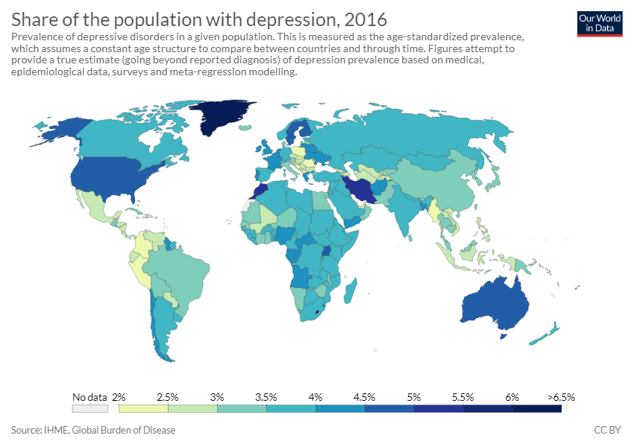
Today, there are many issues concerning the mental health of the general population. While it is normal for people to experience emotional distress as they mature and grow or even due to being put in stressful situations that are caused by everyday life. It is common for people to experience bouts of depression, anxiety, stress but these problems amongst youth and the general public are becoming more prevalent in the more recent generations. More than 300 million people, 4.4% of the world’s population, suffer from depression. These alarming figures reflect the wider prevalence of mental ill-health more generally. It is estimated that mental health conditions will affect a staggering one in four people at some time in their lives.

Along with preventing mental illness, another issue is caring and providing the necessary treatment to those who may find themselves struggling with mental health issues. These treatments may range anywhere from various types of therapies such as drug therapy or even cognitive therapy. Countries do have programs in place such as Mental Health America which try to change the public's view towards mental health making it easier for people to speak out but not all programs are always reliable or accessible, and many nations do not view mental health as a global or societal issue choosing to ignore it causing suffering among those who are in need of treatment. Due to a lack of assistance, people often turn to means of self-harm such as alcoholism, cutting and suicide. It is your job to come up with a solution so that people who are in need of assistance are able to affordably access treatment such as therapy or necessary prescriptions.
Countries such as China, Russia, North Korea and more are also negatively impacting mental health. They, as well as others, are involved in many different cults of personalities. These cults are made to worship an idea or leader and are usually promoted by the government. Cults restrict society to only allow people to think about what the government wants them to think. Other restrictions such as only allowing specific hairstyles and a requirement that citizens follow a specific way of life were found in North Korea and other countries. These restrictions can mentally damage society because people can feel constricted. Having penalties of certain thoughts can harm a person because they can’t be themselves and speak their minds which can then lead to depression. Mental health can be developed due to many different factors such as beauty standards or difficult situations caused by the government, society or even the environment. Thus, there are many problems in terms of mental health that are being caused by natural and unnatural forces and it is up to you as a committee to come up with ways to prevent mental illness and provide aid for people with mental illnesses.

Points to Consider:
- Does your country enforce any restrictions among society, and if so, what are they?
- Does your country contain any programs to better mental health?
- Is treatment accessible and affordable for those who need it?
- Does your country view mental health as a global issue?
Helpful Links:
http://www.euro.who.int/en/health-topics/noncommunicable-diseases/mental-health/data-and-statistics
http://www.who.int/whr/2001/media_centre/press_release/en
https://youth.gov/youth-topics/youth-mental-health
https://www.nimh.nih.gov/health/statistics/prevalence/any-disorder-among-children.shtml
https://www.healthpovertyaction.org/news-events/mental-health-world-health-day-2017/

