PatMedMUNCXII
United Nations Office for Outer Space Affairs

Space Waste Management

The United Nations Office for Outer Space Affairs has focused their attention on preventing and minimizing space debris. Similar to climate change and the need for sustainable development, space debris is a huge global concern as it affects every country who relies on satellites in their daily life. The overall goal of the UNOOSA should be to avoid collisions between waste objects. A syndrome known as the Kessler Effect, is a scenario in which the density of objects in the Low Earth Orbit grow so high that collisions between objects could cause a huge cascade. It can generate more space debris and have serious consequences on people’s everyday satellite-based services, such as navigation, communication devices or weather and climate monitoring.

There are several countries that are major contributing to space debris. Specifically, the United States is the most responsible, followed by Russia and China. The chart below shows that Russia has the most space debris, around 6,500 objects. However, the United States contributes the most, which is a direct result of the American daily activities. Space junk that is left behind after missions, rangings from rocket stages to paint flakes. Even tiny pieces could cause serious damage or even destroy satellites.
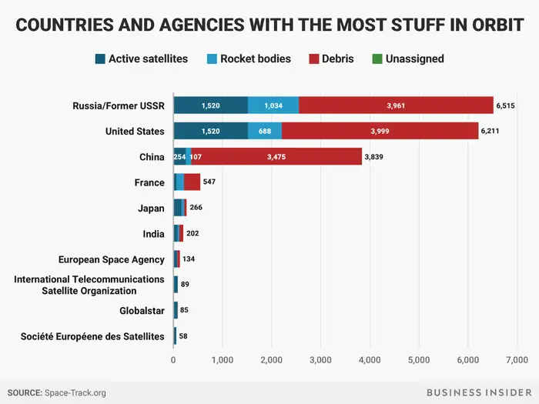

At the Committee's Scientific and Technical Subcommittee, organizations represent information on their space debris research while the Legal Subcommittee discusses the legal aspects of space waste. According to the 1968 Rescue Agreement, states are required to take steps in rescuing astronauts returning them to the Launching State, and that States shall provide assistance in recovering space debris. There is a huge amount of space debris that is currently floating in space right now, especially Earth. According to current models, there are around 130 million waste objects in space, ranging from just a few mm in size up to many metres. Out of this humongous number, over 900,000 pieces are considered to be a threat and because of their big size, they can damage or destroy the entire spacecraft.
Delegates should be able to coincide with one another to come up with the best possible solution to eliminate space debris. It is the ultimate goal of the countries to work together to come up with solutions in order to clean up the debris, reuilize it, or relocate it. A long-term solution needs to be put in check before disaster strikes and causes catastrophic events on Earth. It is essential to clean up outer space and promote international cooperation in the peaceful uses of outer space and assisting developing countries in using space science.

Points to consider:
- Has your country contributed to space debris?
- Has your country sent any missions to space?
- What measures has your country taken to avoid space waste?
- Does your country have any international agreements that cover space debris mitigation?

Helpful links:
https://www.businessinsider.com/space-debris-garbage-statistics-country-list-2017-10
https://www.businessinsider.com/space-junk-debris-amount-statistics-countries-2018-3
https://www.esa.int/Safety_Security/ESA_and_the_United_Nations_team_up_for_space_debris
https://www.unoosa.org/pdf/publications/st_space_49E.pdf
https://asgardia.space/en/news/UNOOSA-and-the-ESA-Join-Forces-to-Combat-Space-Debris

