THE UN PEACEKEEPER REFORM
UN Peacekeeping plays an incredibly important role in settling conflicts, and ensuring that the conflicts remain settled. Just as the name suggests, their main function is to keep the peace, but they also help ensure the implementation of peace agreements. The authorization of peacekeeping operations is the responsibility of the Security Council, as is detailed in Chapter VII of the United Nations Charter. Despite all the good peacekeepers do, in recent years peacekeepers’ missions have been sending them to increasingly hostile environments. The demand for peacekeeping has also increased, and it is simply not being met.
The failure to remedy all situations in which peacekeeping is needed can be attributed to a number of factors, but one of the main reasons is a lack of trust between governing bodies and the peacekeeping program. This lack of trust causes governments to take extra time ensuring that everything is being done properly. Building trust between the peacekeeping program and the governments of nations who are affected by it is an important step in reforming the peacekeeping program. When peacekeepers are deployed on missions, a challenge they often face is unclear mandates that lack focus and have no political solutions behind them. Peacekeepers are often sent into dangerous environments without proper equipment and personnel. This unpreparedness has contributed to a rise in peacekeeper injuries and fatalities.
In response to these issues, The New Horizon process was initiated in 2009, and was intended to assess the major challenges that peacekeepers were encountering, and open up communication on the topic of peacekeeping with stakeholders on how the program could be improved. This resulted in an internal document which reflected both the perspective of the Department of Peacekeeping Operations and The Department of Field Support. The document emphasized the importance of a reinvigorated dialogue, however its overall goal was to forge a peacekeeping policy agenda that “reflects the perspectives of all stakeholders in the global peacekeeping partnership.”

In 2014, following the example that The New Horizon process set, former Secretary-General Ban Ki-moon created a panel to focus specifically on UN Peace Operations. It was intended to focus on assessing the current state of the peacekeeping program, and what would have to change in the future. They created a comprehensive review which took various aspects of peacekeeping into account, including the various challenges facing the program.
The current Secretary-General launched his Action for Peacekeeping, which called on various parties, including the Security Council, to “renew our collective engagement with UN peacekeeping and mutually commit to reach for excellence.” The Secretary-General’s goal for this reform was to reach a formal agreement by the end of 2017. This reform includes the assessment of what changes need to be made to support successful mandate implementation. Ideally, this action will increase the amount of preventative and early action being taken by peacekeepers, rather than them turning up only after outbreaks of violence.
In terms of funding, the budget for UN Peacekeeping operations for 2019-2020 is $6.5 billion. The United States and China are currently the top countries funding the UN peacekeeping budget, the US contributing 27.89% of the overall budget, and China contributing 15.21%. Ethiopia and India are also integral contributors, providing the most UN peacekeepers globally.
Although many steps have been taken by various branches of the UN to reform and better the peacekeeping system, there is still plenty of room for improvement. The Security Council has a responsibility to uphold global safety and peace to the fullest extent possible. Steps must be taken in the future to increase communication and discussion regarding peacekeeping, ensure the safety of peacekeepers as much as possible, and ensure that peacekeepers are able to be where they need to be to subdue conflict as efficiently as possible.
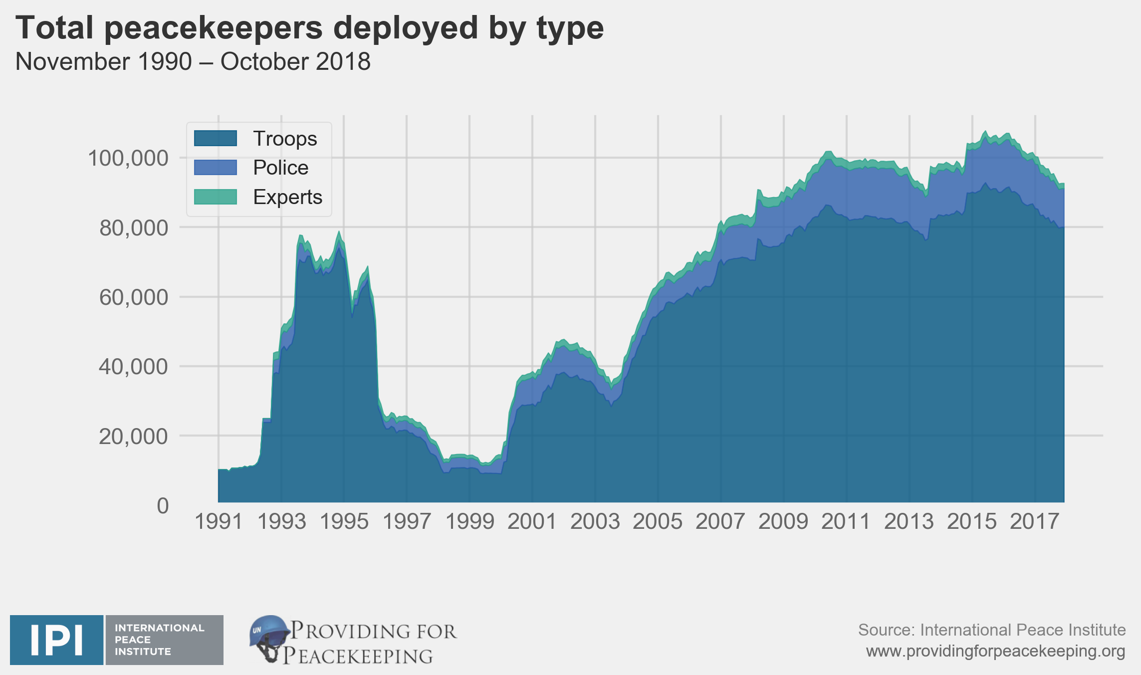
Points to consider:
- How has your nation been affected/benefited from the use of peacekeepers in the past?
- How does your nation’s government feel about allowing peacekeepers into their territory?
- Is your nation included in any existing protection mandates that involve the use of peacekeepers?

Helpful links:
(See hyperlinks throughout guide)
https://peacekeeping.un.org/en/reforming-peacekeeping
https://www.un.org/en/sections/un
https://www.un.org/sg/en/content/sg/statement/2014-10-31/secretary-generals-statement-appointment-high-level-independent
https://bestdelegate.com/united-nations-peacekeepers-which-countries-provide-the-most-troops-and-funding/

