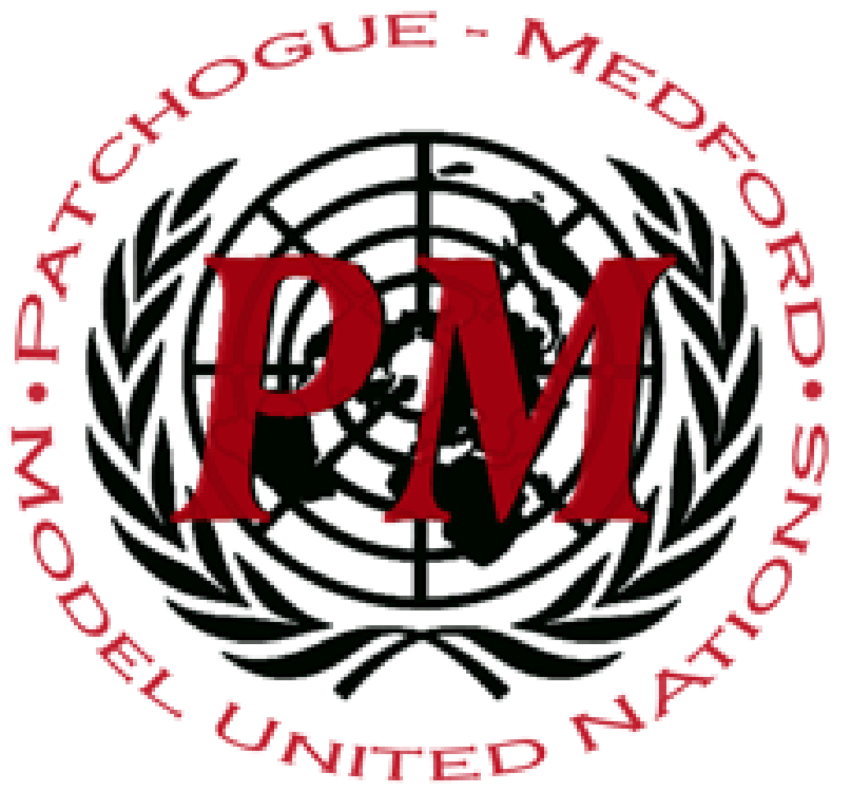
PatMedMUNCXII
Security Council
Turkish Invasion Of Syria
The Turkish invasion of Syria began on October 9, 2019. The Turkish air force launched airstrikes on bordering towns of Syria. The strikes were the cause of more than 70 civilians in Syria and 20 civilians in Turkey, and according to the United Nations, nearly 180,000 people have been displaced since the Turkish offensive began. Turkish forces displayed a shameful regard for civilian life and carried out serious violations, war crimes, killings, and unlawful attacks.
The Turkish President Recep Tayyip Erdogan reported that the operation was intended to expel the terrorist organization, SDF, because of their ties with Kurdistan. The Kurds are the largest ethnic minority in Syria. They live mostly in the north of the country, close to the border with Turkey. The attacks were also intended to create a “safe zone” in Northern Syria, that would pose as a settling point for the 3.6 million Syrian refugees in turkey. The original inhabitants of the proposed “safe zone” were heavily Kurdish, which shows intentions of a forced drastic demographic change from Turkey. Turkey denied these allegations, but with little evidence to prove otherwise.
The international community condemned Turkey for the attacks. Many countries imposed arms embargoes on Turkey, and stopped selling arms to Turkey. The U.S. continued their involvement in the Syrain-Turkish affairs by imposing sanctions on Turkish ministries. The U.S. also pulled its forces out of Syria, proving as a betrayal to the Kurds.
The Syrian Government originally blamed The Kurdish forces for the attacks from Turkey. The government blamed the Kurds for being separate from the Syrian Government. However, The Syrian Government allowed the Syrian Army the attacked towns of Manbij and Kobani to protect the towns from Turkey. The Syrian Government also deployed Syrian Army Troops in the country’s north. Meanwhile, Turkey launched an attack to capture Manbij.
On October 17, 2019, U.S. made an agreement with Turkey to a ceasefire in Syria for 5 days. In return, there would be a complete withdrawal by the Syrian forces from a safe zone south of the Syria-Turkey border. In addition, on October 22, 2019, Russia and Turkey agreed to an extension of the ceasefire by 150 hours as the Syrian Forces would move an extra 30 kilometers from the border area.

Points to Consider:
- What is your countries relationship to Turkey? Syria?
- Is your country involved in the attacks?
- How does your country wish to respond to the attacks?
Helpful Links:
https://www.apnews.com/1f69e48442a3452d85914d0db917632a
https://www.politico.eu/article/8-questions-about-turkeys-incursion-into-syria-answered/
https://www.npr.org/sections/goatsandsoda/2019/10/25/773458865/unicefs-top-syria-official-we-have-witnessed-huge-amounts-of-distress-among-kids

